**Using Google Analytics to Power SeattleSpots:**

**A Data-Driven Travel Website**

**Member Names**

* Mustafa Bhavanagarwala
* Ming-Yeh Chiang
* Jake Chan
* Pravalli Budida
* Zehao Chi

**Site Mission Statement**

The website is dedicated to showcasing the best travel attractions in Seattle and Washington state, offering visitors a comprehensive guide to must-visit locations, hidden gems, and cultural landmarks.

**Site Content Strategy**

Real‐World Content Examples:

### **Visit Seattle (visitseattle.org)**

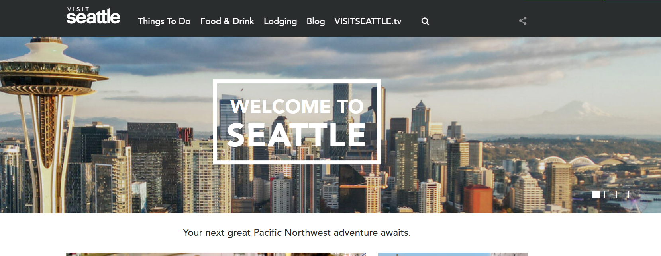

One of the leading examples in travel and tourism websites is **Visit Seattle**, which organizes its content around intuitive menu items such as “Things to Do,” “Places to Stay,” and “Events.” This categorization helps visitors quickly locate relevant topics. Another noteworthy element is the site’s mix of descriptive editorial pieces and logistical information—allowing readers to immerse themselves in city narratives (e.g., “Savor Seattle’s Culinary Scene”) while also finding practical details (maps, schedules, or contact info for attractions).

Relevance to Our Strategy:

* **Balanced Content:** Visit Seattle combines stories (think “Top Outdoor Adventures”) with more functional guides (e.g., “Hotel Directory”). This approach is great with a blend of narrative‐style blog posts and quick guides.
* **Timely Updates:** Seasonal or event‐specific pages (like upcoming festivals) keep returning visitors engaged. There is a plan to incorporate a similar structure in the monthly “Seattle Spotlight” updates.

### **Lonely Planet’s Seattle Section (lonelyplanet.com/usa/seattle)**

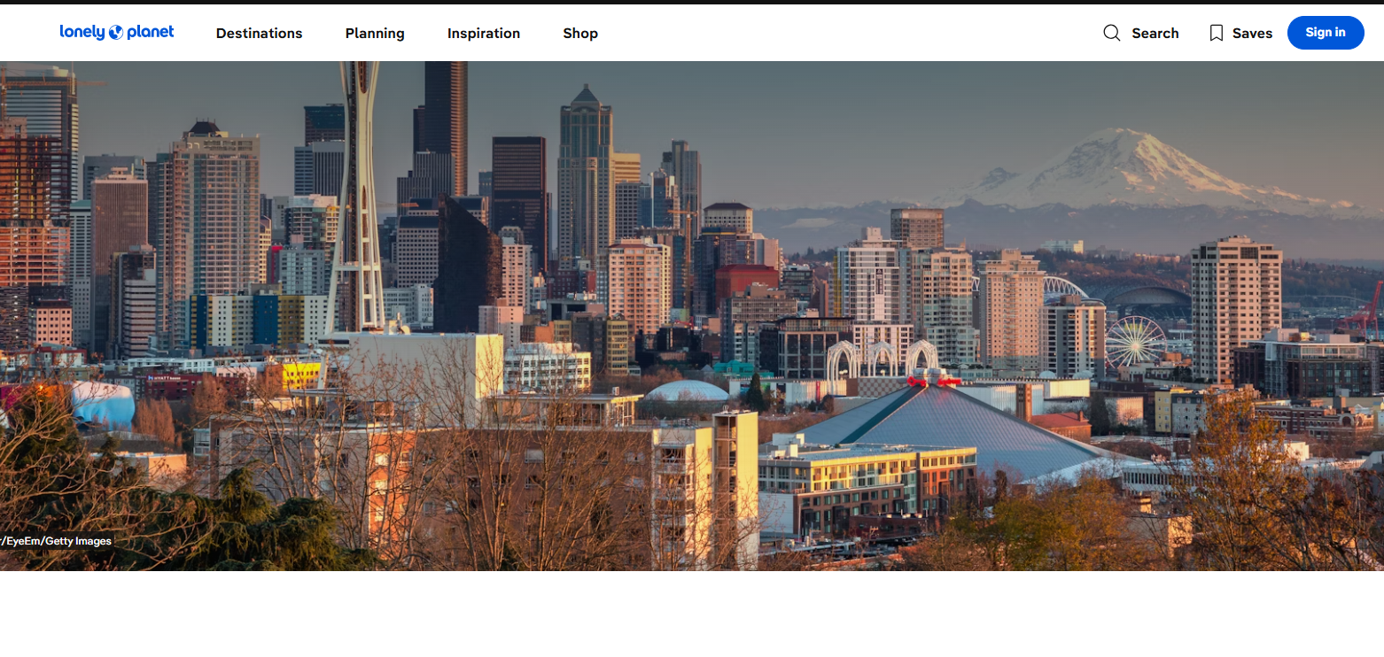

On Lonely Planet, Seattle is showcased as a must‐see destination through a combination of top experiences, practical planning tips (e.g., when to visit, typical costs), and “travel stories” that emphasize unique cultural elements. It often merges concise bullet points (for quick reference) with well‐developed articles that provide richer context.

Relevance to Our Strategy:

* **Layered Content Depth:** The site caters to both “skimmers” who want quick bullet‐point recommendations and those who enjoy reading in‐depth guides. Our site similarly pairs short “Top 3 Scenic Spots” lists with lengthier “Deep Dive” posts about Seattle’s hidden gems.
* **Interlinking:** Lonely Planet seamlessly interlinks posts, guiding users from one topic to related content. We’re adopting the same approach to keep users exploring different areas of Seattle on our site.

**Our WordPress Site**

### a. Organized Navigation and Categories

Drawing inspiration from both Visit Seattle and Lonely Planet, our navigation menu is organized by categories such as **Iconic, Top Scenic Spots, Museums, Coffee Fix,** and more. This categorization ensures visitors can quickly find relevant information, whether they’re looking for an iconic landmark or a deep dive into Seattle’s coffee culture.

* **Parent Categories:** Reflect major interest areas (e.g., “Iconic”).
* **Subcategories/Posts:** Cover specific attractions (e.g., “Seattle Great Wheel”).
* **Tags:** Used to highlight related topics (e.g., “waterfront,” “skyline,” “Ferris wheel”), improving site search and content discovery.

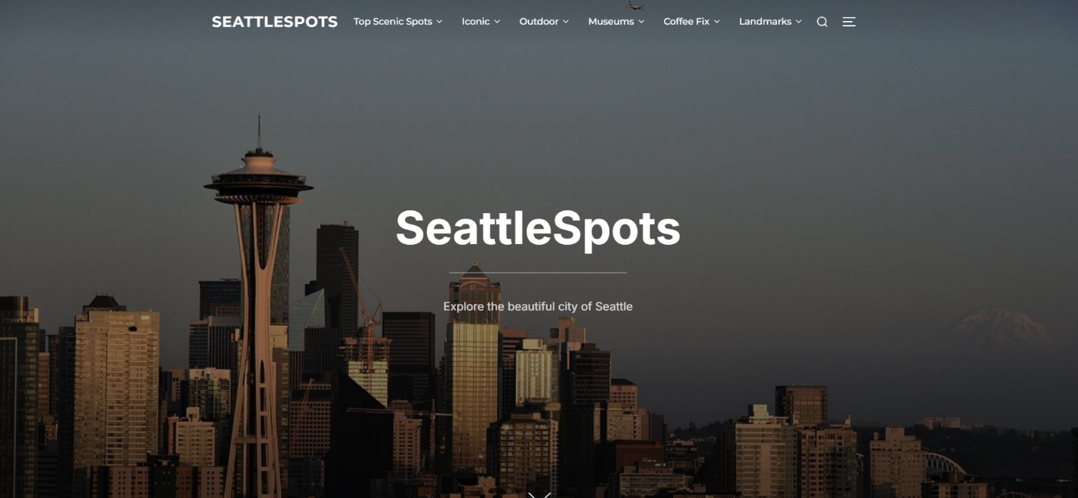

### b. Captivating Content and Regular Updates

Consistent with real‐world best practices, we aim to publish new content weekly. Each post includes:

1. **A Clear, Engaging Title** – e.g., “**A Bird’s Eye View of the Waterfront**”
2. **Introductory Paragraph** – Summarizing the purpose of the post and hooking the reader.
3. **Optimized Images** – Placed strategically throughout the text
4. **Supporting Links** – Linking to related content within the site, creating an easy path for further exploration.

We manage all content via **Posts > Add New** in the WordPress dashboard, assigning each entry to its category and setting a featured image to display prominently on our home page and archive pages.

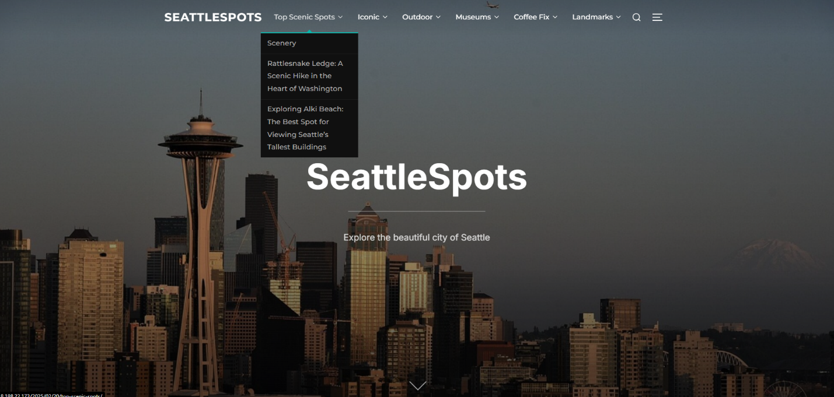

### c. Visual Storytelling

Both Visit Seattle and Lonely Planet rely on compelling visuals to immerse viewers in the travel experience. Our own use of **hero images** on each page and prominent photos in blog posts showcases the character of Seattle—like the vibrant neon sign of Pike Place Market or sweeping views from Kerry Park.

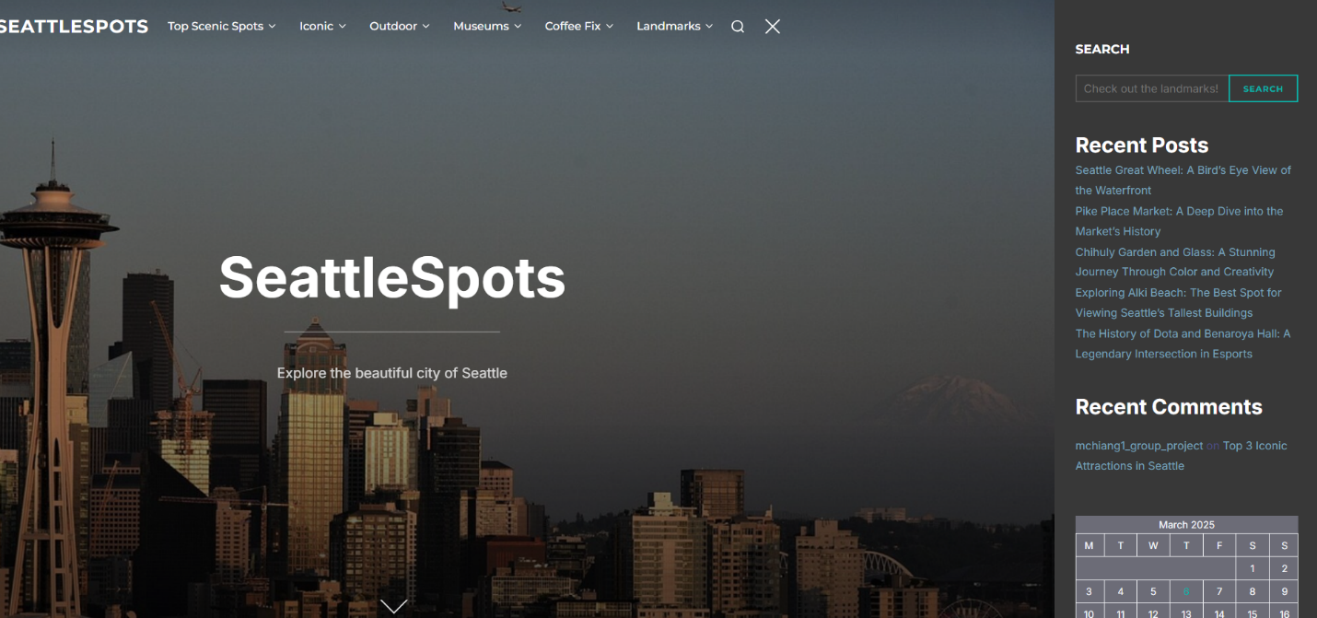

### d. Encouraging User Engagement

Following Lonely Planet’s lead, we invite readers to leave comments, share their own tips. This interactive element, facilitated by plugins encourages community building. It also offers insights into what content resonates with visitors, helping us refine future posts.

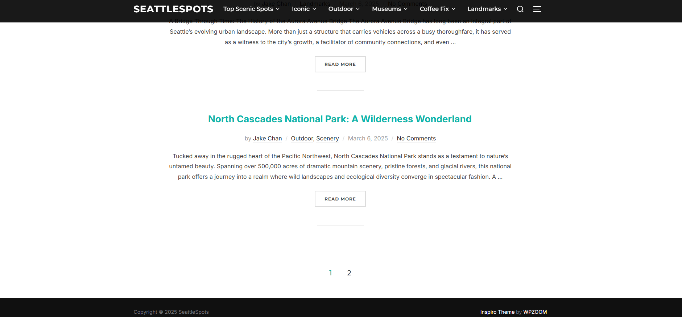

**Site Design Strategy**

### **Real-World Design Examples and Their Relevance**

### a. National Geographic Travel (travel.nationalgeographic.com)

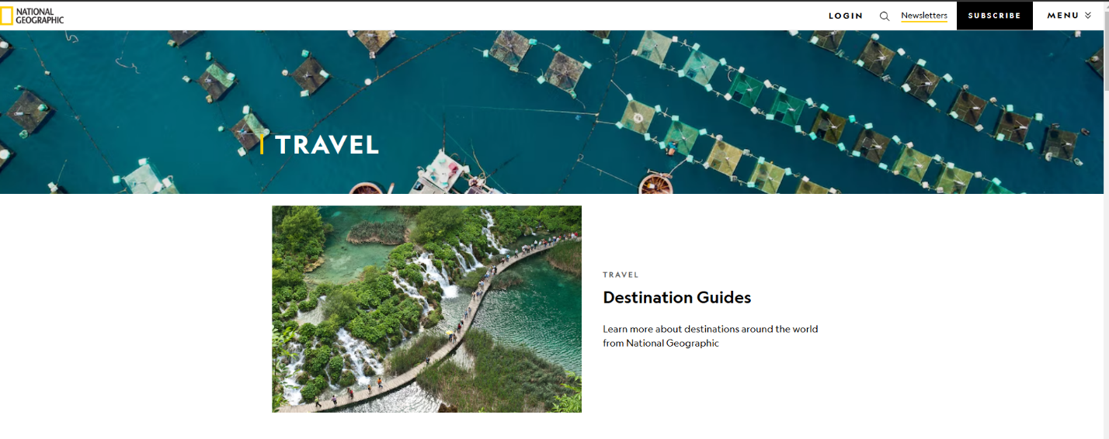

One of the best examples of a visually rich and well-structured website is **National Geographic Travel**. Their design focuses on large, **high-quality imagery**, immersive storytelling, and an intuitive **category-based menu system**.

#### Key Design Features:

* **Full-Screen Hero Images:** Each travel destination page features a striking full-screen image, drawing the reader in immediately.
* **Category-Based Navigation:** The menu is divided into sections like “Destinations,” “Experiences,” and “Photography,” making it easy for users to browse specific topics.
* **Dynamic Content Blocks:** The homepage features a mix of top articles, featured guides, and interactive maps, keeping content visually engaging.

#### Relevance to Our Website:

* Our **homepage also uses a large hero image** showcasing the Seattle skyline, creating an immediate **visual impact**.
* We have implemented **category-based navigation** (e.g., “Iconic,” “Top Scenic Spots”), similar to National Geographic’s “Destinations.”
* **Using high-quality images** in our blog posts (e.g., “Seattle Great Wheel”) ensures an engaging and **aesthetic user experience**.

### b. The Culture Trip (theculturetrip.com)

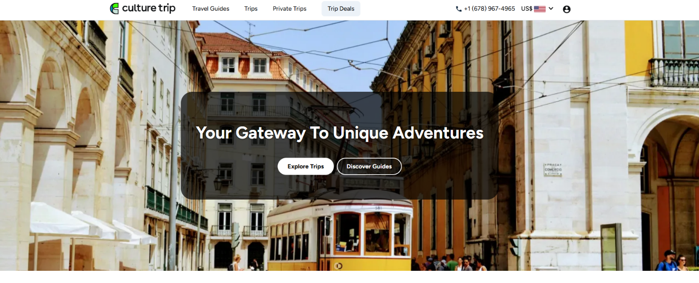

Another well-designed travel and culture site is **The Culture Trip**, which blends a **modern minimalist aesthetic** with easy-to-use navigation.

#### Key Design Features:

* **Clean, Grid-Based Layout:** Articles are displayed in a structured **card-based format** for easy readability.
* **Sticky Header Menu:** The top menu remains visible as users scroll, improving accessibility.
* **SEO & Readability Focus:** Articles are formatted with short paragraphs, bullet points, and strong **calls to action (CTA)** for better engagement.

#### Relevance to Our Website:

* Our **grid-based blog post layout** ensures readability, much like The Culture Trip’s structure.
* The **menu structure in “SeattleSpots” stays visible** at the top, aiding navigation across different sections.
* Articles in “SeattleSpots” are formatted with **concise paragraphs and headers**, making them **scannable and user-friendly**, just like The Culture Trip.

## **Analysis of Our Website’s Design, Theme, Plugins, and Menu Structure**

### a. Theme Selection: Inspiro Theme by WPZOOM

As shown in the **footer screenshot**, our WordPress site uses the **Inspiro Theme by WPZOOM**. This theme is well-suited for visually rich content, making it an ideal choice for a travel and tourism website.

#### Features of Inspiro Theme:

* **Full-Screen Hero Images** (Used on the homepage with Seattle’s skyline).
* **Responsive & Mobile-Friendly Design** (Adapts well on smartphones and tablets).
* **Lightweight & SEO Optimized** (Ensures fast loading times and search engine visibility).

Why We Chose It:

* Inspiro’s **media-friendly design** aligns with our focus on photography-heavy content.
* The **dark background with bright highlights** provides a **modern, professional** look.
* The theme supports **featured image thumbnails**, ensuring **each blog post has an engaging visual preview**.

### b. Plugin Usage and Functionality

Plugins enhance the functionality of our WordPress website

#### Active Plugins and Their Roles:

1. **Google Analytics for WordPress by MonsterInsights**
   1. Tracks visitor behavior and site performance.
   2. Helps identify the most popular blog posts (e.g., “Top 3 Iconic Attractions in Seattle”).
2. **Site Kit by Google**
   1. Integrates **Google Search Console** and **AdSense**, improving SEO and monetization.
3. **TaxoPress**
   1. Manages **categories, tags, and taxonomies** efficiently.
   2. Ensures **better content organization**, making posts more discoverable.
4. **WP Headers and Footers**
   1. Allows adding **custom scripts** (like Google Tag Manager) for advanced analytics tracking.

Impact on Site Design & User Experience:

* Google Analytics **guides content strategy** by identifying high-traffic pages.
* TaxoPress **improves internal linking**, boosting SEO rankings.
* WP Headers and Footers helps integrate external tracking tools **without modifying theme files**.

### c. Menu Structure and Navigation

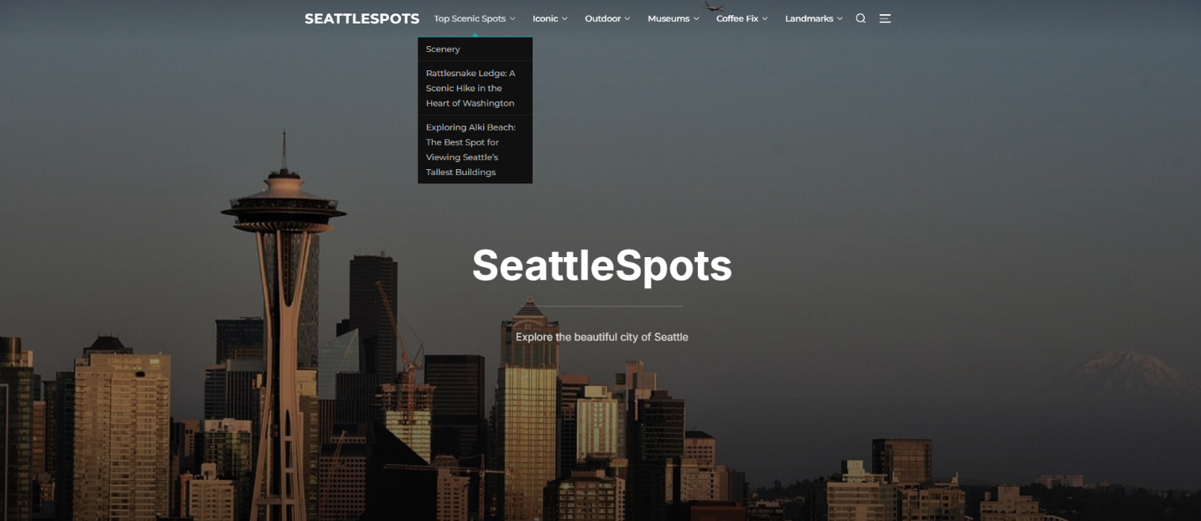

As shown in the **menu structure screenshots**, our website follows a **clear, hierarchical menu system** that improves **user accessibility** and **SEO performance**.

#### Key Menu Sections and Subcategories(example framework):

1. **Top Scenic Spots**
   1. Rattlesnake Ledge: A Scenic Hike in Washington
   2. Exploring Alki Beach
2. **Iconic**
   1. Top 3 Iconic Attractions in Seattle
   2. Seattle Great Wheel
3. **Outdoor**
   1. Discovering The Majestic Falls
   2. North Cascades National Park
4. **Museums**
   1. Exploring the Museum of Pop Culture
   2. Chihuly Garden and Glass
5. **Coffee Fix**
   1. Best Cafés Beyond Starbucks
6. **Landmarks**
   1. History of Dota & Benaroya Hall
   2. Fremont Troll: Seattle’s Urban Legend

Why This Menu Structure Works:

* **Easy to Navigate:** Users can **quickly find** attractions based on their interests.
* **Logical Subcategories:** Grouping posts under broader topics (e.g., “Outdoor” or “Museums”) enhances readability.
* **SEO Benefits:** Well-structured menus improve **search engine discoverability** for tourism-related searches.

**Site Metrics Strategy**

***Explore Template(s) from GA4 'Explore | Analysis'***

Our team leverages the **Funnel Exploration** template in GA4 to analyze user behavior across key website interactions, tracking their journey from visiting the homepage to engaging with content. The funnel examines user progression through actions such as clicking on a blog post, scrolling and clicking “Read More,”.

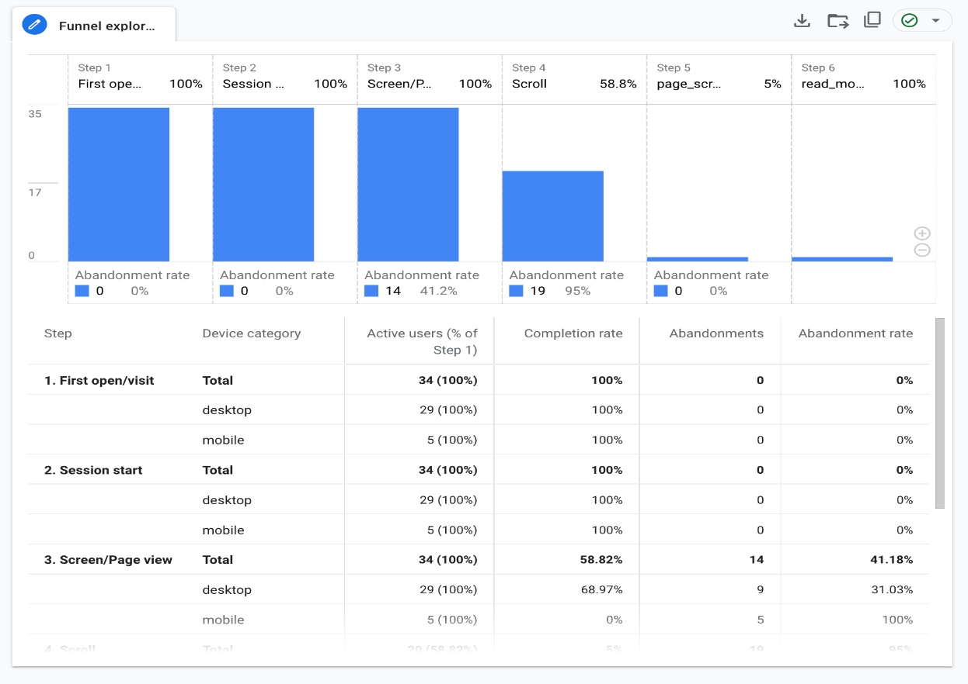

Our analysis highlights significant drop-off points, notably at the scrolling stage, where user count drops from 16 to 8, and in deeper engagement, as only three users click “Read More.” To address these issues, we are thinking of enhancing scroll engagement by incorporating compelling headlines, visuals, and interactive elements, as well as A/B testing different page layouts.

Additionally, improving “Read More” click-through rates can be achieved by making the button more prominent through size, color, or positioning and experimenting with stronger CTA wording like “Explore More” or “Start Now.” These optimizations aim to refine our content strategy, improve user retention, and enhance overall engagement.

***'Events' in GA4***

The GA4 Events report showcases key interactions that users have with our website, including page views, user engagement, scrolling behavior, and session starts. Over the last 28 days, the total event count reached 452 across 37 users, indicating that users are actively engaging with the site. Notably, “page_view” and “user_engagement” are the most frequent events, suggesting that visitors are spending time exploring multiple pages and interacting with content. The steady increase in event activity toward the end of the reporting period reflects growing user interest.

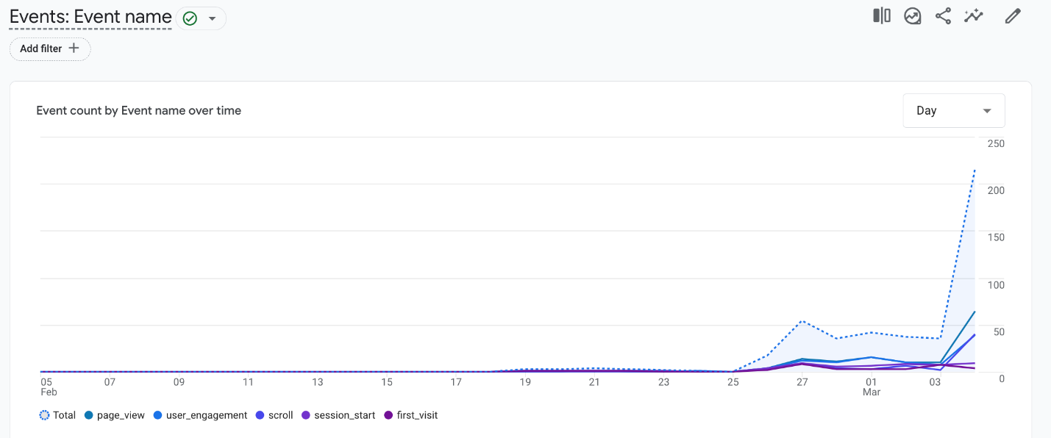

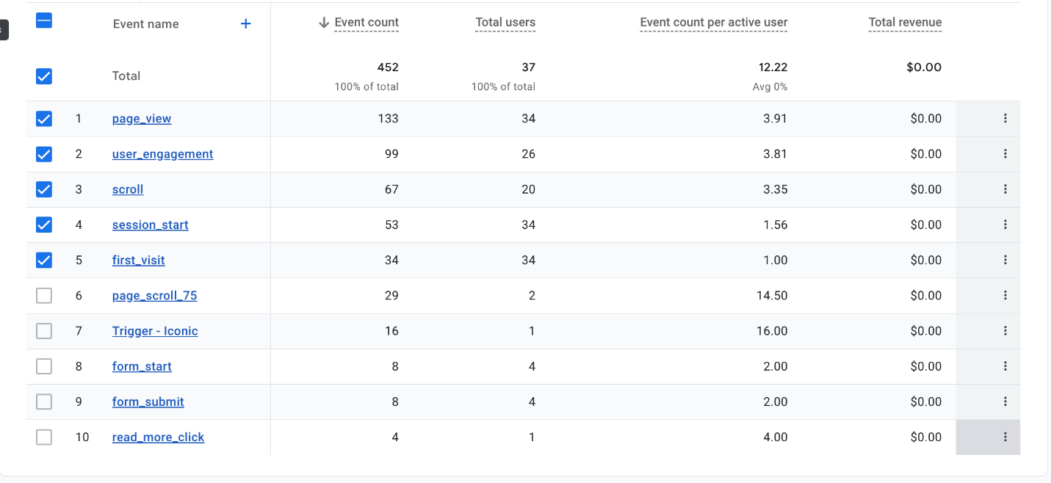

Specific event interactions, such as “scroll” and “first_visit,” help us measure audience behavior beyond just page views. The presence of “form_submit” events indicates that users are engaging with interactive elements such as commenting on our posts. The “read_more_click” event further highlights user interest in diving deeper into content. Understanding these events helps us identify which features drive engagement and which areas might need improvement. Additionally, page_scroll_75 captures when users scroll 75% down a page, providing insights into how much content is being consumed.

By analyzing these event trends, we can refine our user experience strategy to encourage more meaningful interactions. For example, if high scroll depth and engagement time correlate with certain types of content, we can focus on producing more of that content. These event-driven analytics help us understand how users interact with the website, allowing us to optimize content layout, engagement strategies, and overall user experience.

***Preliminary Analysis:***

Our team has analyzed the Google Analytics reports for our WordPress website, and the data shows promising growth in user engagement. Over the past 3 weeks, we had 37 active users, with a significant spike in the past week (32 users) and 6 users on the most recent day. This upward trend suggests increased interest in our content, likely due to improved visibility. However, to sustain this momentum, we should explore strategies to keep our audience engaged and encourage repeat visits.

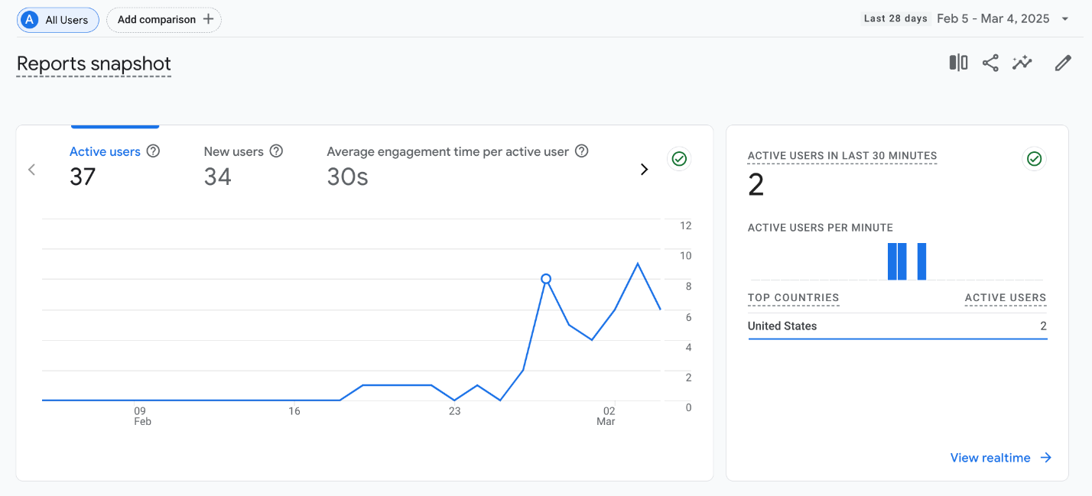

When looking at our top-performing pages, **“SeattleSpots – Explore the beautiful...”** leads with 82 views, followed by **“Top 3 Iconic Attractions in Seattle” (30 views).** Other pages, like **“Top Scenic Spots – SeattleSpots” (12 views)** and **“Seattle’s Best Outdoor Attractions” (9 views),** have considerably lower traffic. This highlights the need to optimize or promote less-visited pages through better internal linking or keyword adjustments. Additionally, our event tracking shows strong engagement with **133 page views, 99 engagement events, and 67 scroll events,** indicating that visitors are interacting with our content rather than bouncing off immediately.

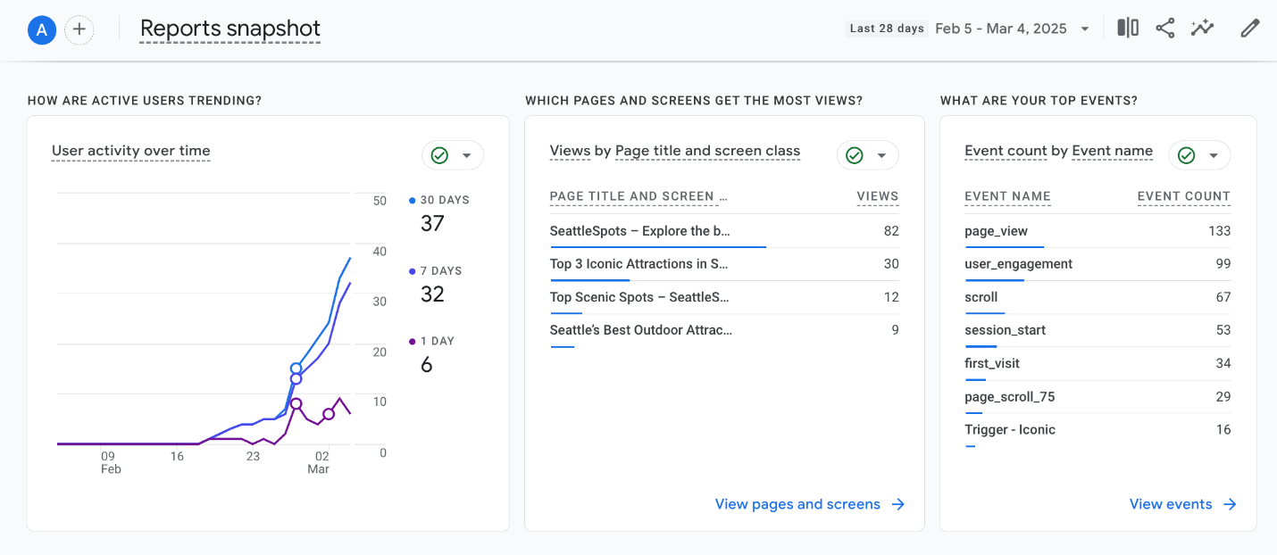

To capitalize on this momentum, we can implement a few key strategies:

* **Enhance internal linking** to guide users from high-traffic pages to those with lower engagement.
* **Improve CTA placements** on popular pages to drive deeper interactions.

**Site Content Strategy with analytical insights**

Based on data trends, our team can refine the content strategy by addressing key areas of improvement. If certain pages exhibit a high bounce rate, we must identify whether the issue stems from unengaging content, slow page load times, or irrelevant information. Pages with high exit rates require closer examination to determine if users are leaving due to a lack of compelling content or navigational difficulties.

To address these issues, we can enhance content clarity, introduce interactive elements, and refine the page structure to improve readability and engagement. Additionally, analyzing user engagement metrics, such as the most viewed and interacted-with blog posts, can help us tailor our content strategy. If specific topics, such as "Best Travel Destinations in 2025," generate significant traffic and shares, we can prioritize creating similar content to align with audience interests.

Incorporating multimedia elements such as images, infographics, and videos can further boost engagement by making the content more visually appealing and informative. Through these adjustments, we can ensure that our content remains relevant, engaging, and aligned with user preferences.

**Site Design Strategy with analytical insights**

Analyzing user behavior and engagement metrics allows the team to refine the website’s design strategy to enhance user experience and retention. If data indicates a high drop-off rate on specific pages, we must assess whether poor navigation, cluttered layouts, or unresponsive design elements are contributing factors.

To address these challenges, optimizing site navigation, and ensuring a clean, intuitive layout can significantly enhance usability. Additionally, if users are not interacting with key elements, such as call-to-action buttons or interactive features, adjustments in visual hierarchy, button placement, and contrast can drive better engagement.

Heatmaps and session recordings can further provide insights into user behavior, helping us identify design bottlenecks and areas for improvement. By continuously iterating based on analytical findings, we can create a visually appealing, user-friendly design that aligns with audience expectations and enhances overall site performance

**References:**

* HubSpot. (n.d.). Interactive content examples to boost engagement. Retrieved February 19, 2025, from <https://blog.hubspot.com/marketing/interactive-content-examples>
* Moz. (n.d.). SEO for travel websites: Strategies for boosting visibility. Retrieved February 19, 2025, from <https://moz.com/blog/seo-travel>
* State of Washington Tourism. (n.d.). Explore Washington. Retrieved February 19, 2025, from <https://stateofwatourism.com/>
* Visit Seattle. (n.d.). Official Seattle travel and tourism guide. Retrieved February 19, 2025, from <https://visitseattle.org/>